MEMO

**To:** Traci Gardner

**From:** Student Names Removed for Privacy

**Date:** April 16, 2023

**Subject:** Research Proposal for Recommendation Report: Accessibility in Selected Residence Halls

# Introduction

Virginia Tech’s Office of Equity and Accessibility has an entire division dedicated to ADA & Accessibility Services. This department is “committed to equal opportunity in employment and education for individuals with disabilities and complies with the Americans with Disabilities Act (ADA), as amended, the Rehabilitation Act, as amended, and other state and local laws that apply to individuals with disabilities.”1

Regardless of this focus at the university-level on accessibility for students with disabilities, several residence halls on campus actually violate those standards because they include features detrimental to ADA accessibility. For example, Pritchard Hall has two elevators that give students access to all of its seven floors; however, several of the floors contain stairs mid-floor that lead to separate levels. Newman Hall also falls below accessibility standards because it does not have handicap push buttons on any of its doors.

For the project in this course, we will study accessibility in various residential halls through surveys and field research. We hope to document several examples of each problem and recommend at least one feasible solution per problem.

# Project Overview and Rationale

Accessibility is an increasing need on-campus if Virginia Tech hopes to admit and accommodate current and future disabled students, faculty, and visitors. Virginia Tech, as beautiful as it is, was founded in 1872 and went through 100 years of construction before the Americans with Disabilities Act (ADA) was passed in 1990. As a result, many buildings on campus weren’t designed with the disabled in mind and while Virginia Tech has largely updated its buildings to comply with the ADA, some gaps remain.

The problem Virginia Tech faces is that while key accessibility features have been introduced, some legacy buildings constructed before the ADA was passed still provide challenges for disabled students. Newman Hall, for example, has elevators to each floor, but steps mid-floor prevent disabled students from navigating the building easily (see Figure 1 below). Many dorms lack automatic door buttons, requiring wheelchair users to either wait for another student to open the door for them, or they have to try to open the door while in their wheelchair. These

1 https://oea.vt.edu/ada-accessibility-services.html

accessibility gaps could be solved by minor accessibility improvements, and provide great benefit to disabled Hokies.

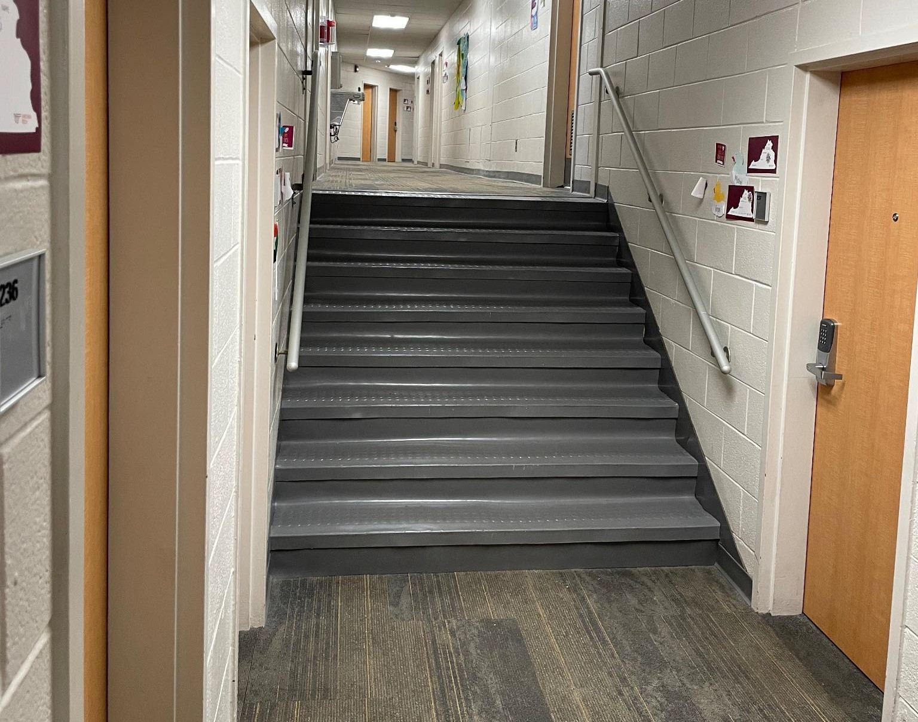

Fig. 1 Image of mid-floor steps located on the 2nd floor in Newman Hall.

According to section 12182(B-2-A-ii) of the Americans with Disabilities Act, public entities are required to make reasonable modifications in policies, practices, and/or procedures when the modifications are necessary to avoid discrimination on the basis of disability, unless the public entity can demonstrate that making the modifications would cause undue hardship or fundamentally alter the nature of the service, program, or activity.” Given Virginia Tech’s commitment to ADA, the university should be more aware of situations on campus that put it in violation of federal policy. Regardless of whether older buildings are “grandfathered in” and are not required to be updated, ADA compliance is an ethical commitment that should be followed.

We hope that our project will identify key areas of ADA compliance concern for the university and impress upon administrators the need to rectify existing problems.

# Project Methodology & Resources

Our team will collect and document data materials that violate ADA requirements. Through the efforts listed below, we will create an informative resource to support our recommendation so a feasible solution is possible.

First, we will visit all residential halls and document findings to determine if each building requires necessary additions or alterations. For the sake of time and effort, we will exclude Greek life. Significant findings include:

* Sufficient number of wheelchair accessible doors
* Presence of handicap buttons
* Inaccessible areas within each floor
* Any significant handicap discrimination

Second, we will also post QR code surveys around residential halls to encourage student contribution to our content analysis. Questions will ask for noticeable hindrances against possible disabled people. It will also ask non-disabled participants if they themselves have encountered accessibility issues. This is asked under the assumption that difficulties for able-bodied individuals will most likely pose worse hardships for those with disabilities.

Third, we may interview cleaning staff for key insight on the ins and outs of the buildings. This is due to their extensive knowledge of floor plans as well as their experience with operating cleaning tools through all parts of the building.

Finally, we plan to contact the ADA and Offices of Services for Students for further inquiry about the issue. We will request assistance in evaluating whether these projects qualify as a

non-capital renovation and how to submit an Interdepartmental Service Request (ISR). We will ask questions and gather materials to help construct a possible solution.

# Project Audience

This proposal is intended for the ADA team, Office for Equity and Accessibility, and Campus Planning, Infrastructure, and Facilities. Contacts for review include

*ADA Case Manager* Lacey Canterbury

[laceyc@vt.edu](mailto:laceyc@vt.edu)

*Director for ADA, Accessibility Services, and 504 Coordinator*

Pamela Vickers

[pvickers@vt.edu](mailto:pvickers@vt.edu)

*Associate Vice President for Equity and Accessibility*

Kelly Oaks

[koaks@vt.edu](mailto:koaks@vt.edu)

*Vice President of Campus Planning, Infrastructure, and Facilities (VPCPIF)*

Chris Kiwus

[chkiwus@vt.edu](mailto:chkiwus@vt.edu)

We have chosen the above ADA team members because they offer exclusive insight and influence over accessibility projects. We have chosen the Office for Equity and Accessibility for their promotion of 504 compliance, and VPCPIF for their authority over Virginia Tech Design and Construction Standards. We will contact these individuals through email to demonstrate the viability of our proposal.

# Project Personnel

**Student 1** is a junior in Public Relations with a minor in Professional and Technical Writing. She plans to graduate in Spring 2024. As a student living on campus, she has witnessed the lack of disability accommodation throughout the residential halls, specifically her own dorm (Newman Hall). She understands that every dorm is slightly different, but is also mindful of disabled people, including her own dorm neighbor. This individual drives her to think critically about the limitations all residential halls pose to disabled people.

**Student 2** is a junior in Professional and Technical Writing with a minor in Strategic Communication. She has noticed the lack of accessibility in her own dorm, Newman Hall, and a friend’s dorm, Hillcrest Hall, which she frequently visits. This issue started pressing on her mind after she witnessed a disabled student struggling to enter Newman Hall due to the lack of automatic door buttons.

**Student 3** is a junior in Business and Information Technology with a focus in Cybersecurity management and analytics. He spent his freshman year in Hoge Hall, and witnessed firsthand the lack of accommodations for wheelchair-bound students trying to get to the lowest level rooms.

# Project Timetable

Work on this project will take place across the following dates.

|  |  |  |  |  |  |  |  |  |  |
| --- | --- | --- | --- | --- | --- | --- | --- | --- | --- |
|  | **10-Apr** |  | **16-Apr** |  | **19-Apr** |  | **28-Apr** |  | **5-May** |
| **Research Prop. Draft** |  |  |  |  |  |  |  |  |  |
|  |  |  |  |  |  |  |  |  |  |
| **Research Prop. Final** |  |  |  |  |  |  |  |  |  |
|  |  |  |  |  |  |  |  |  |  |
| **On-site Research** |  |  |  |  |  |  |  |  |  |
|  |  |  |  |  |  |  |  |  |  |
| **Other Research** |  |  |  |  |  |  |  |  |  |
|  |  |  |  |  |  |  |  |  |  |
| **Progress Report** |  |  |  |  |  |  |  |  |  |

|  |  |  |  |  |  |  |  |  |  |
| --- | --- | --- | --- | --- | --- | --- | --- | --- | --- |
|  |  |  |  |  |  |  |  |  |  |
| **Rec. Report Draft** |  |  |  |  |  |  |  |  |  |
|  |  |  |  |  |  |  |  |  |  |
| **Recommend ation Report** |  |  |  |  |  |  |  |  |  |

# Conclusion

As previously stated, Virginia Tech’s Office of Equity and Accessibility has an entire division dedicated to ADA & Accessibility Services. Despite this, there are still significant accessibility barriers present in many, if not all, of the residential dorms. These barriers include mid-floor steps, lack of automatic door buttons, and minimal elevators. Virginia Tech should spend resources to correct these simple issues which would create more equal opportunities for all disabled individuals and benefit the campus as a whole. This improvement to campus will provide ease for all disabled students, faculty, and visitors that frequent the dorms.

Please let us know if you approve of our subject. If you have any questions, please contact Student 3 (email@vt.edu).